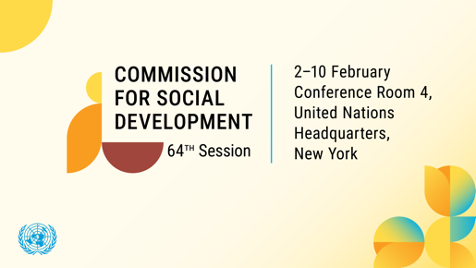

Upholding Human Dignity: Addressing Homelessness through Inclusive Social Protection

A virtual side event at the 64th Session of the UN Commission for Social Development (CSocD64)
Thursday February 12 2026, 9:30 - 11:00 am (EST)
Zoom registration link: https://us02web.zoom.us/meeting/register/ITOM83PnS7On3js0qm1jHA
Among the most urgent challenges today is the persistence of homelessness, which undermines the fundamental principle of human dignity, and exposes the gaps in social protection systems worldwide.

Human dignity is the cornerstone of all human rights and social justice frameworks, enshrined in documents such as the Universal Declaration of Human Rights. It affirms the inherent worth of every person, regardless of their circumstances, background, status, or abilities. Yet homelessness represents a direct violation of this dignity, stripping individuals of safety, privacy, and access to basic services. This poses a direct affront to human dignity and remains a persistent challenge in rich and poor countries throughout the world.

According to the United Nations, over 2.8 billion people lack adequate housing. UN Habitat reports that over 318 million people worldwide are estimated to be completely homeless. The causes are diverse – ranging from poverty, unemployment, lack of affordable housing, mental health issues, natural disasters, and systemic inequality. Vulnerable groups, including children, women, youth, migrants, persons with disabilities, and indigenous populations, are disproportionately affected.

Gender bias in global homelessness is reflected in that while men form the majority of visible/sheltered homeless populations, women experience higher "hidden" homelessness and vulnerability to violence, leading to systemic data gaps and inadequate support. Women's homelessness is frequently linked to domestic violence, sexual assault, lack of affordable childcare.

Social protection systems are crucial for upholding human dignity by ensuring individuals have access to basic necessities and support during life's challenges, preventing poverty and social exclusion. According to the most current United Nations Sustainable Development Goals Report 2025, for the first time on record, over half of the world’s population now receives at least one form of social protection benefit. Despite this milestone, 3.8 billion people remain uncovered.

To meaningfully address homelessness, social protection systems must be holistic, accessible, and rights based. They should:

- Address its root causes, such as poverty, domestic violence, lack of access to healthcare, and inadequate housing, by implementing preventative measures respectively.
- Provide mental health services and wrap around services with Trauma Informed Care (TIC).

- Empower individuals through education, job training, and pathways to stable employment

What is needed is for rights based social protection systems and floors which emphasize:

- Universality: Ensuring that everyone has access to basic support without discrimination
- Participation: Involving people experiencing homelessness in the design, implementation, and evaluation of programs
- Accountability: Establishing clear mechanisms for monitoring and redressing violations of rights
- Empowerment: Fostering autonomy and self-determination through support that builds capacities at local and national levels.

Social protection systems, when well-designed and robustly implemented, offer a pathway to restore dignity and empower those with a lived experience of homelessness. The collection of accurate and disaggregated data is essential to better inform programs and policies to address homelessness. Housing must be recognized as a human right, not merely as a commodity.

The speakers and participants of the side-event will share best practices’ projects that uphold human dignity for homeless and vulnerable in similar situations, present aspects of the intertwined social protection and homelessness policies and explore possible innovative partnerships between various stakeholders on action-oriented commitments.
Homelessness is solvable. By centering human dignity and expanding social protection, the global community can forge a pathway towards inclusive development and social justice.

List of speakers:

- Dónal Cronin, Deputy Permanent Representative, Permanent Mission of Ireland to the UN

- Maren Andrea Jimenez, Social Affairs Officer, UN Department of Economic and Social Affairs

- Jean Quinn, Former Executive Director, UNANIMA International, Past Chair of Working Group to End Homelessness

- Sylvia Beales Gelber, Founder Member, Global Coalition for Social Protection Floors

- Maryann Broxton, Main Representative to the United Nations, ATD Fourth World (lived experience)

Closing remarks: Jackie Shapiro, Co-Chair, Working Group to End Homelessness

Moderator: Dr. Despoina Afroditi Milaki, UN Representative, International Presentation Association

The side-event is organized by:
International Presentation Association | Permanent Mission of Ireland to the UN | NGO Working Group to End Homelessness
and
co-sponsored by ECPAT-USA | International Association of Charities | Soroptimist International | Apne Aap Women Worldwide

