**CSOCD63 - SIDE EVENT**

**February 13, 2025, (1:15 - 2:30pm EST) Hybrid**

**TITLE -** "Building a Collective Future: Grassroots Voices on Emerging Priorities for the Second World Social Summit."

***Organized by: NGO Committee for Social Development, and the UN Department of Economic and Social Affairs***

***Co-sponsored by the Permanent Mission of Portugal to the United Nations***

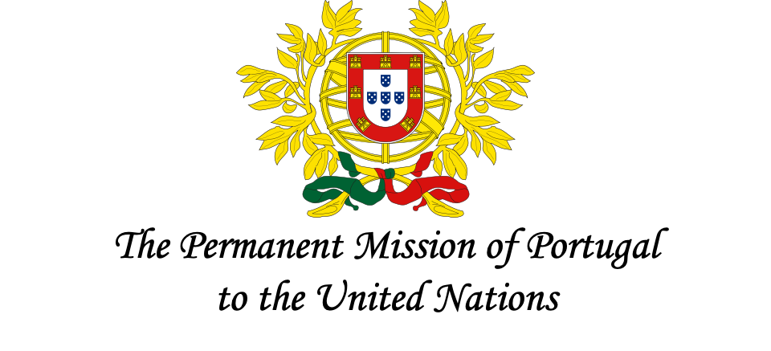

Thirty years after the Copenhagen Declaration and the establishment of the Programme of Action from the first World Social Summit, 700 million people still live in extreme poverty, struggling to meet their basic needs, to access opportunities, to live a dignified life and have a strong voice in the society.

As we approach the second World Social Summit in 2025, it is essential to identify the most critical issues preventing the world from achieving social inclusion, cohesion, collective resilience, and development. Local communities, particularly those on the frontlines of poverty and social injustice, have a unique understanding of the challenges they face and the solutions that work. If we are to make progress toward the proposed “people-centered development” of the Copenhagen Declaration, it is crucial to give a voice to all vulnerable and marginalized people who suffer from poverty and exclusion. Their input in the process ensures that the issues we aim to prioritize are relevant and timely, especially in a fast-changing, complex world. Grassroots solutions also offer valuable insights for addressing global challenges.

This side event, organized by the NGO Committee on Social Development and cosponsored by the UN DESA Division for Inclusive Social Development, will highlight grassroots realities, including emerging issues which have surfaced since the Copenhagen Declaration. In addition, resilient solutions will be shared from local communities and individuals facing and/or addressing social challenges.

By showcasing these grassroots voices, we aim to bring attention to what is needed to shape a more inclusive and equitable world. Featuring grassroots voices from around the world and

experts who will then discuss these insights, we will explore key concerns and ideas to design global strategies and guide the Second World Social Summit toward impactful decisions. This event is an opportunity to connect local knowledge with global action, ensuring that the upcoming Summit reflects the needs and ideas of the people most affected by social inequalities.

Speakers’ list:

* **Mr. Jorge Aranda**, Deputy Permanent Representative, Permanent Mission of Portugal to the United Nations
* **Ms Marta Roig**, Senior Social Affairs Officer, UN DESA Division for Inclusive Social Development