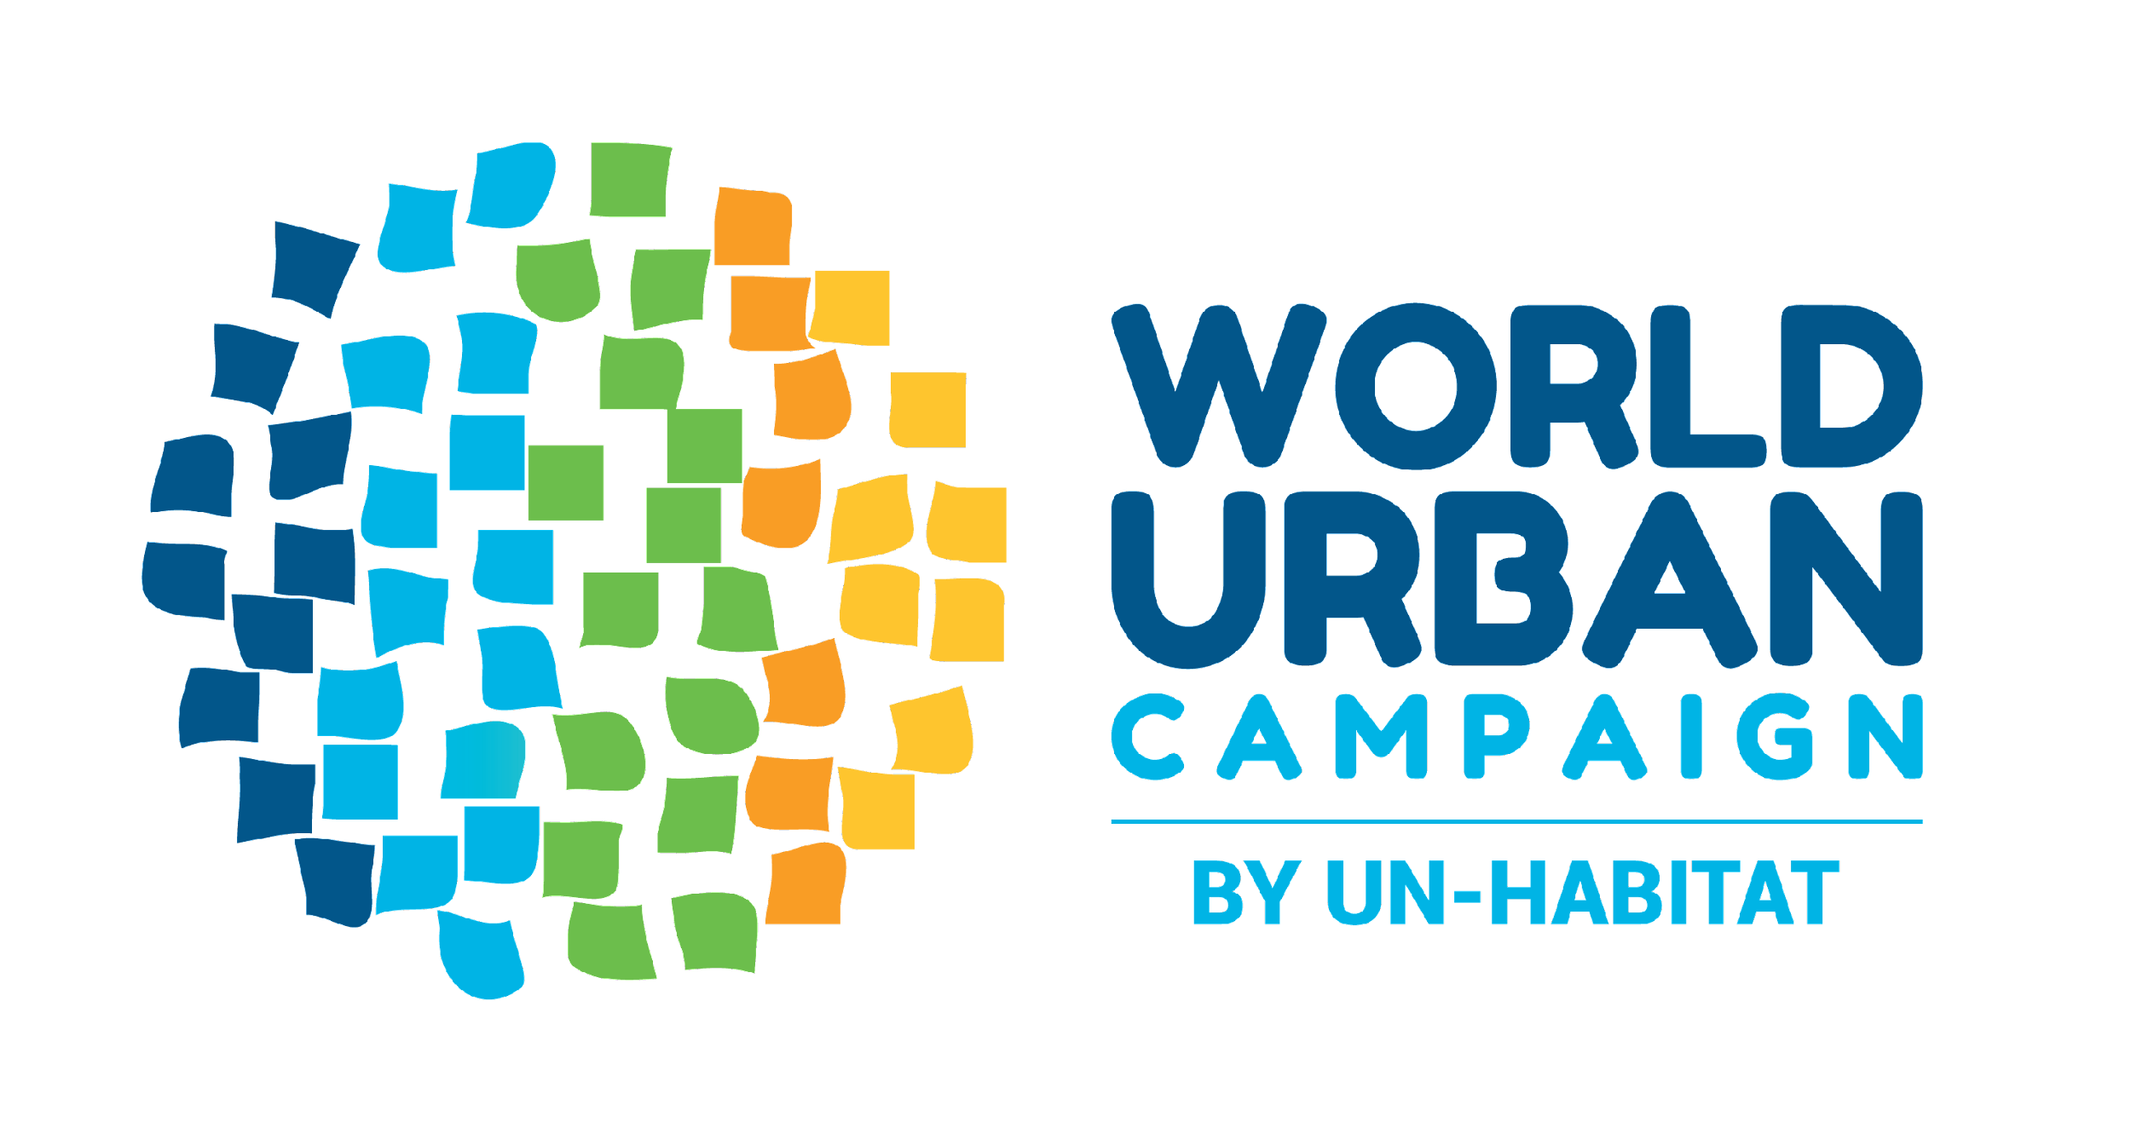
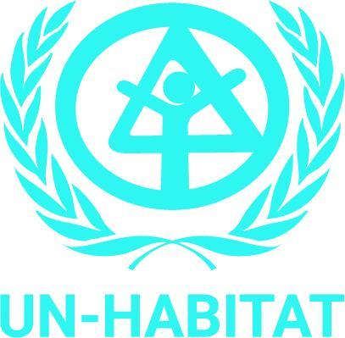
CSW68 (2024)
UN Headquarters, New York

World Urban Campaign Session

#HousingMatters to Women and Girls

Adequate housing to achieve gender equality and the empowerment of all women and girls.

Date: Monday 18-Mar-2024
Time: 4:45 PM - 6:00 PM (75-minutes)
Venue: Conference Room D,UN Headquarters, New York
Event number: 240530

Organisation of the Event:
UN-Habitat

Background:
The sixty-eighth session of the Commission on the Status of Women (CSW68) will take place from 11 to 22 March 2024. Representatives of Member States, UN entities, and ECOSOC-accredited non-governmental organizations (NGOs) from all regions of the world are invited to contribute to the session. The priority theme is ‘Accelerating the achievement of gender equality and the empowerment of all women and girls by addressing poverty and strengthening institutions and financing with a gender perspective’. The review theme is about ‘social protection systems, access to public services and sustainable infrastructure for gender equality and the empowerment of women and girls’.

Housing is a fundamental element to accelerate the achievement of gender equality and the empowerment of all women and girls. This aspect is related to SDG Target 11.1: By 2030, ensure access for all to adequate, safe and affordable housing and basic services and upgrade slums. In the SDG11 report represented during its review at the High Level Political Forum 2023, two key actions to accelerate this target are:
- Promoting multiple housing finance options can improve access to adequate housing.
- Active and broad political participation is essential to ensure access to safe, adequate and affordable housing and basic services in all communities.

#HousingMatters is a global campaign led by the World Urban Campaign of UN-Habitat in 2024-25 to advocate for the recognition of housing as a fundamental right that shapes our environment, well-being, and the future of our planet.

In particular, #HousingMatters to Women and Girls:
- Because worldwide at least 1.8 billion people don’t have access to safe, affordable and adequate housing. Women and girls are disproportionally affected by the global housing crisis, as a result of discrimination and inequality in housing, living in insecure, undignified and unsafe conditions, at increased risk of homelessness and violence.
- Forced evictions and other violations of the right to housing, disproportionally impact women and reinforce existing inequalities, representing a significant barrier to gender equality.
- Adequate housing is key to women’s survival. With less than 40% of women participating in the labor force globally, women and children are most often the victims of housing-related fatalities simply because they spend more time at home.
- Housing is more than a roof over women and girls heads. Housing is their first line of defense against climate change and health risks. A clean, hygienic and safe living space promotes better physical health, reduces the risk of diseases, and contributes to improved mental well-being, allowing them to thrive in all aspects of life. Adequate housing allows women and girls to live in dignity and thrive.

One of the important targets for SDG11 is Target Target 11.1: By 2030, ensure access for all to adequate, safe and affordable housing and basic services and upgrade slums. In the SDG11 report represented during its review at the High Level Political Forum 2023, two key actions to accelerate this target are:
- Promoting multiple housing finance options can improve access to adequate housing.
- Active and broad political participation is essential to ensure access to safe, adequate and affordable housing and basic services in all communities.

Objectives of the session:
- To introduce the #HousingMatters Campaign to the women’s constituency, governments, donors and other development institutions.
- To share, present and discuss practices led by women organisations, governments and development institutions that highlight community-based and women innovations and leadership in designing policy programme and funding mechanisms for women to own houses and sustainable communities.
- To make recommendations related to housing policies and programmes that works for women and girls.

Expected Outcomes:
- Enhanced visibility of the #HousingMatters Campaign by UN-Habitat.
- Strategic collaboration amongst stakeholders in innovative policies and programmes that center-stage women’s contributions, leadership, needs and roles.
- Recommendations on housing policies and programmes that works for women and girls.

Speaker & Panelists:
- Introduction: Paula Pennanen-Rebeiro-Hargrave, Deputy Director, NY UN-Habitat Office
- Panelists :
  - H.E. Ambassador Muhammad Abdul Muhith, Permanent Representative of Bangladesh to the United Nations
  - Lana Louise Finikin, Huairou Commission Governing Council Vice Chair
  - Mino Ramaroson, HUairou Commission Africa regional Coordinator & Land-Specialist
  - Jean Quinn, Director, UNANIMA International
  - Jane Onyango, Director, Polycom Development, Kenya
- Moderator: Angela Mwai, Head, Human Rights and Social Inclusion Unit, UN-Habitat

Proposed Agenda (1 hr 15 mins session ):

Time | Description | Details
3 mins | Welcoming Remarks  - Moderator: Angela Mwai | Moderator Introductions of panelists + setting the scene
5 mins | Opening remarks by H.E. Ambassador Muhammad Abdul Muhith, Permanent Representative of Bangladesh to the United Nations
4 mins | Introduction to the World Urban Campaign (WUC) and the Global #Housing Matters Campaign  - Paula Pennanen-Rebeiro-Hargrave, Deputy Director, NY UN-Habitat Office | #Housing matters - A global campaign to ensure that housing is recognized as a fundamental need that shapes our environment, well-being, and the future of our planet. Because housing matters, we need to unite and act together
15 mins | The housing crisis has reached unprecedented levels, exacerbated by the profound effects of the COVID-19 pandemic and the deepening inequalities resulting from a convergence of crises stemming from climate change impacts and conflicts. Financial repercussions and escalating disparities further compound the challenges, impacting countries, cities, and communities on a global scale.  Adequate and affordable housing has become an urgent imperative to address the rising shelter deficit, making people increasingly vulnerable to heat waves, floods, storms and other adverse climate change impacts. It is estimated that the world needs to build 96,000 new affordable homes every day to house the estimated 3 billion people who will need access to adequate housing by 2030. | Panelists Discussion of Guiding Question 1: What are some of the challenges that your government/organisation observes on housing issues and why do they matter to women/how do they impact women?  3-4 mins per speaker
15-mins | In most cultures, it is women and girls who are primarily responsible for sustaining and maintaining the home, as well as all of the care responsibilities that come with it. However, there are also less women in decision-making spaces on the development and design of housing related ;policies -planning (location), financing, design etc | Panelists Discussion of Guiding Question 2: How is your government/organisation working with partners to address the empowerment of women and girls to access housing?  3-4 mins per speaker
15-mins | Call for Action/Sharing of Good Practices-Tools & Recommmendation(s) | Panelists Discussion of Guiding Question 3: Can you share a good practice/tool and/or recommendation that center-stage women’s contributions, leadership, needs and roles; and work for them.  3-4 mins per speaker
10 mins | Q+A with Audience
7 mins | Summary and Closing Remarks

